Term 2 Week 6 June 2019

Principal’s Report

Welcome to Term 2 everyone – what an action packed start with camps, carnivals and construction at Callaghan Waratah.
Year 7 Camp: a great way for our new students to bond
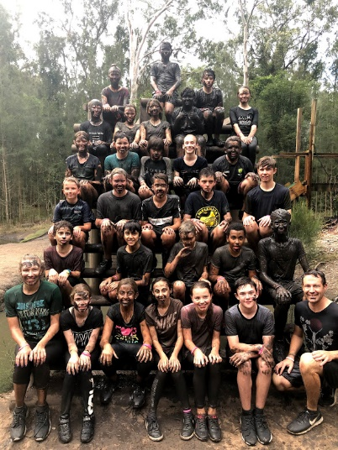
School Camps are always a great experience for students to have fun and learn beyond the classroom setting. During the first week of this term, Year 7 visited The Outdoor Education Centre at Morisset. I was lucky enough to make a day visit and was really proud to see so many students participating in all the adventurous activities and enjoying the great food (and a little mud!). I’d like to thank our parents for your support of school camps, as they are an important part of a child’s schooling experience.
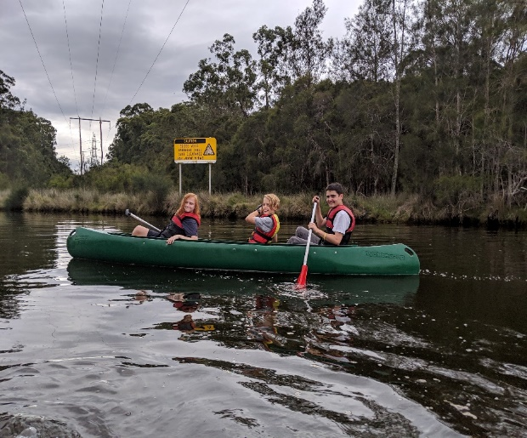

Beautiful spaces continue to thrive around the school
Many of you may have noticed extensive work being completed around the school over the last few months. Our Aboriginal garden near our front entrance is looking wonderful and with some more seating to be added, this beautiful space will soon accommodate a class of 28 as an outdoor learning venue. We have also re-turfed and landscaped many of the lawns and gardens near this area so the school now has a very welcoming entrance from Young Street.
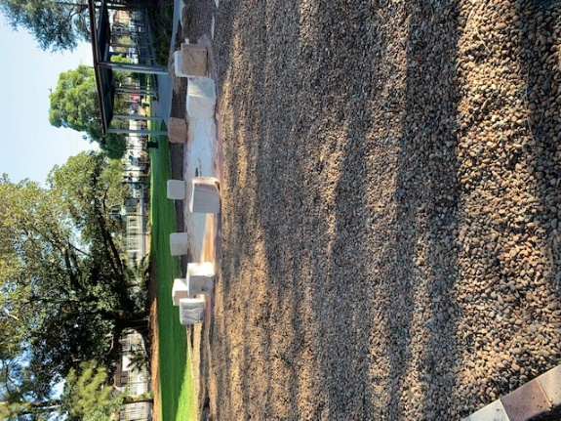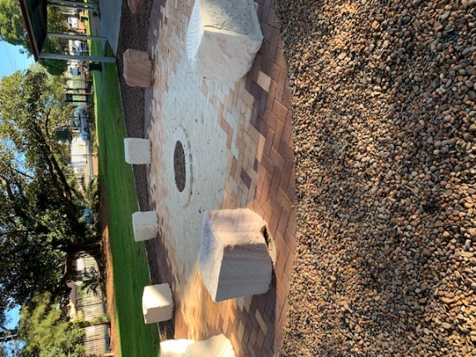
We have also had a number of our large trees removed by the department – this is largely to protect the extensive new work about to commence on the roof of the CAPA block. This building has experienced roof leaks for a long time, and before work could begin the trees had to be cleared to protect gutters and roofing from further damage. This work will take about 6 weeks, and then we can start to beautify the outdoor area.
NAPLAN goes digital
This year we moved to NAPLAN online for Year 7 and 9. I would like to congratulate all students in these year groups who did a great job in the transition from paper to digital technology. Students remained positive and engaged even through some connectivity issues on the first day. Your children never cease to amaze me with their perseverance and team approach to problem solving.
Choosing next year’s High Achievers
In week two we held the High Achiever Class Interviews for incoming Year 7 students in 2020. A number of staff ran panels in our new school library, asking students questions about their learning and their goals for the future. We had a high number of young applicants who impressed us with their love of learning and their desire to be at our College. We wish them well in the outcome of these interviews and look forward to welcoming all our new students next year.
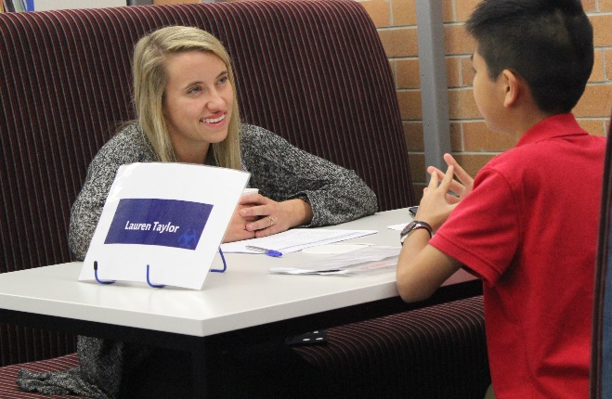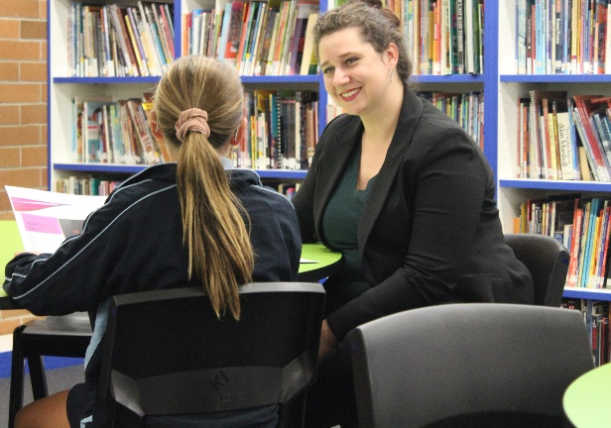

Ms Hayley Macdonald, Principal

Stage 4 Deputy Principal Report
Year 7s started the term with a flurry with many venturing off to Morisset for Year 7 camp. The focus of the camp was on developing skills in teamwork, communication, responsibility, self-awareness and organisation. Students participated in a range of activities, including archery, mud runs, high rope courses and canoeing. They had a fantastic time, enjoying the food, activities and each other’s company. Some even managed to get a little sleep! The following day’s Campus Athletics Carnival was a bit of a struggle for their tired bodies.
I echo Ms Macdonald in congratulating Year 7 students for their positive engagement in NAPLAN testing during weeks 3 and 4 of term. These tests allow students to demonstrate their abilities and I’m sure both students and families are interested to see the outcome of their participation.
Transitions
On Wednesday the 29th May we welcomed over 300 Year 6 students to our campus for Year 6 Transition Day. The students engaged in an exciting day of taster lessons, giving them a glimpse of both the high school environment and learning here at CCWTC. Several of our current Year 7 students have also been visiting their old Primary Schools with teaching staff to share their valuable experience of High School life with their former peers. I’d like to extend my thanks to these students, as well as to those who provided valuable feedback on their transition from Primary to High School as a part of our College Transition Focus Group.
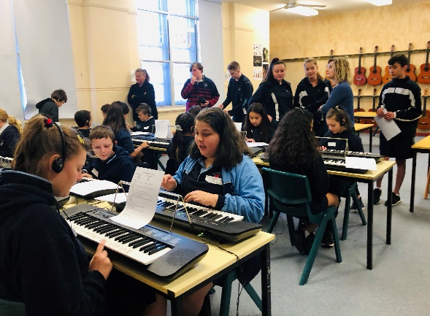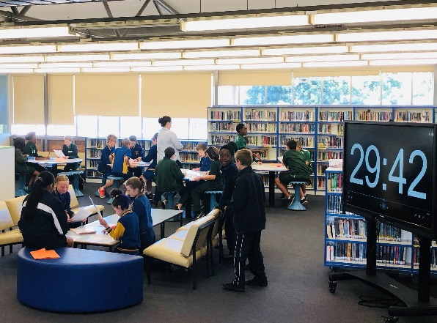

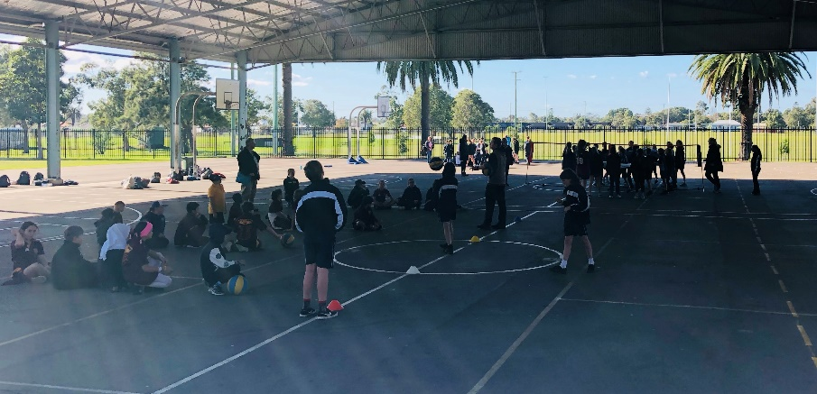
Cyber Safety
Our Year 7 and 8 students will be participating in Cyber Safety presentations, starting on Wednesday 5th June. Led by our Campus School Liaison Police Officer, these presentations provide current information on safe use of digital technologies and how to manage events like cyber bullying. At CCWTC students are permitted to have mobile devices at school, however, they are expected to be used and managed in accordance with our school expectations and not to interfere with the learning or wellbeing of students.
Uniform
With the sudden arrival of the cooler weather, we have started to revisit winter uniform expectations in our PBL morning assemblies. Please ensure students have either the school jumper, or a plain, dark navy jumper to wear. Students are not permitted to wear other coloured jumpers, or to have visible branding or logos on them. Year 10 students take pride in wearing their Year 10 jerseys. The 2019 jersey is uniform for the current Year 10 cohort only. Year 10 jerseys from previous academic years are not considered uniform and are not to be worn by students please. Uniform promotes a sense of belonging in our school community and reflects our school identity in the wider community. Please refer to our campus web page for further uniform information: https://waratah-h.schools.nsw.gov.au/about-our-school/what-we-offer.html
Attendance
Now is a great time to check your student’s school attendance and confirm or explain any absences so far this year. Attendance letters have been issued advising of unexplained attendance, or concerns of high absenteeism. Parents/Carers are required to respond to text attendance notifications or contact our Campus office to provide an explanation for an absence. This is expected to be done within 7 school days. Please provide any relevant medical certificates for frequent or extended leave periods. Additionally, we encourage families to seek assistance from our staff when extended periods of leave are required. For further details please view our web page: https://waratah-h.schools.nsw.gov.au/about-our-school/what-we-offer.html .
Mr Lindsay Morrow,
Stage 4 Deputy Principal

Stage 5 Deputy Principal Report
The first transition events for Jesmond Campus started this term with Jesmond Expo, the first round of subject selections and MyHSC@CC Day 1, setting Year 10 students up for thinking about where they are heading and what they are wanting to achieve. This early start to talking about the Preliminary and HSC courses is something new for all Campuses and seems to be getting positive comments from students. I have had many students earnestly setting targets and asking key questions of myself and Ms Grieve to ensure they are on the right track.
We have a large number of Year 10 students already accessing short TAFE courses and other work-based programs, which give them a taste of what can be achieved through these avenues.
It is just fantastic to see Year 10 students engaging in all sorts of pathways on to the next stage of work or education!
Congratulations to Year 9 as well who have been working at NAPLAN online. This is always a challenge and the students have been fantastic in working with us and doing their very best.
Darren, Mel, Aunty Robin and the kids in the Gunya room have been trying out their skills in the kitchen. Friday has become "Feed the Mob Friday" and is already a great success, feeding over 24 students and staff, with many having seconds.
Hardly any leftovers!!! I think some of these students (OR DARREN) might be going for Masterchef soon!!!
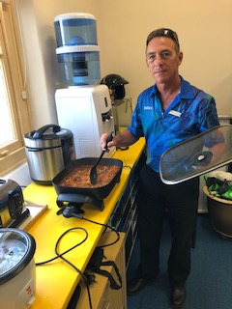

Mrs Nicole Avard,
Stage 5 Deputy Principal

Maths Faculty

What a big start to Term 2 with NAPLAN testing, mathematics exams and Year 10s completing their second assessment task – only two more to go! It’s been great witnessing students striving for their personal best in these tests, as well as in class.
As part of the transition from Year 10 to 11, our Year 10 students joined students from Wallsend Campus for ‘J—Day’ at Jesmond Senior Campus. It was a fantastic day with useful information on course selections, some great entertainment from Jamie Mitchell and his Year 12 CAPA students, and all enjoyed the lunchtime sausage sizzle. Our Year 10 students showed fantastic enthusiasm and demonstrated exemplary behaviours throughout the day. I’d like to thank the Jesmond Campus staff for organising such an important event.
CC Waratah Maths students showed they are ready to progress into Stage 6 during the recent Advanced/Extension Mathematics session. All students engaged in the problems set by Mr Wright and even attempted some of the class work on Surds.
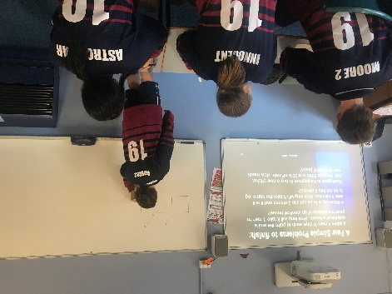
Mr Ian Andrew,
Relieving Head Teacher Mathematics
English as an Additional Language
Welcoming new students
This year we welcome Helene and Esperance from the Congo and Claude and Moses from Rwanda into the Intensive English Class at our school. Each student brings new ideas, thoughts, insights and language.
We are enjoying learning how to say ‘hello’ and ‘thank you’ in many different languages, such as Swahili, French, Kinyarwanda and Kirundi. Many of our new students speak up to four languages and leave the Intensive English Class able to speak another language, English!
Students speak up at Parliament House
On the 8th of April, Coumba, Jawad, Yasamin, Sifa and Toryalai attended the NSW Youth Week Forum at Parliament House in Sydney. Hosted by the Advocate for Children and Young People, the forum was attended by 150 young people between the ages of 12 and 24, from all over NSW. Government departments posed key questions that they wanted answered by young people. For example, “Do you think you can have a better future in a city or a regional town? What does volunteering mean to young people? What would support young people to feel like they belong to their community?” All of our students came away feeling positive and with the feeling that their opinions matter.
Behind the News
Keep an eye out – we might be appearing on BTN soon!
Mrs Kathleen Ozawa,
Teacher EALD
What’s New in the Library?
In the library this term we have had a huge number of requests for books. If you have a book you would really like to read, come and let us know. All of the items pictured have been requested by students and are certain to prove highly popular. We have adventure, graphic novels and many more. Library lovers who made the original request can borrow these books now.
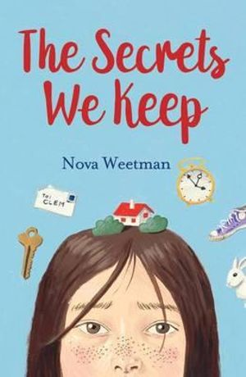
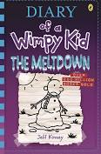
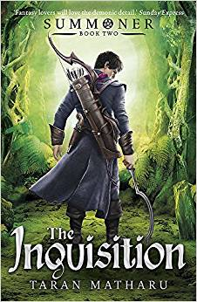
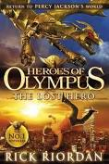

Mrs Brody Seferovic, Librarian

Community Engagement and Promotions Officer Report
Hello CCWTC community. My name is Helen Thomas and it’s an honour to join this wonderful learning community as the new Community Engagement and Promotions Officer.
My role is very much about sharing the amazing achievements and learning experiences of our young people and working with our parents and carers to build a strong community around our children.
It’s a delight to be around and begin to meet our students here at CCWTC. This term, I’ve had students come into my office with arm outstretched to shake my hand, introduce themselves and welcome me to the school. When I’ve been lost around Campus, I’ve had students stop and ask, “Are you ok, Miss? Do you want me to show you the way?” These experiences warm my heart and speak volumes of the qualities of our young people here and the strength of the CCWTC community.
I look forward to meeting many of you in the coming months and continuing to build connections between the school and the community. Please drop by my office to say hello next time you’re at the school. My work days are Mondays, Wednesdays and Fridays. Alternatively, you can email me at helen.thomas28@det.nsw.edu.au

Ms Helen Thomas,
Community Engagement and Promotions Officer
PDHPE Faculty

9/10 PASS Coaching at Waratah Public School
Students from the 9/10 Physical Activities and Sports Studies classes undertook an IBL Project (Inquiry Based Learning) this term. This involved venturing up to Waratah Public School to run some sports coaching with Stage 2 students with the goal of improving their fundamental movement skills. Sports included soccer, touch football, obstacle courses, handball, basketball and netball. Our students were graded on their planning as well as implementation of activities. Thanks to Waratah Public School for facilitating this valuable experience.
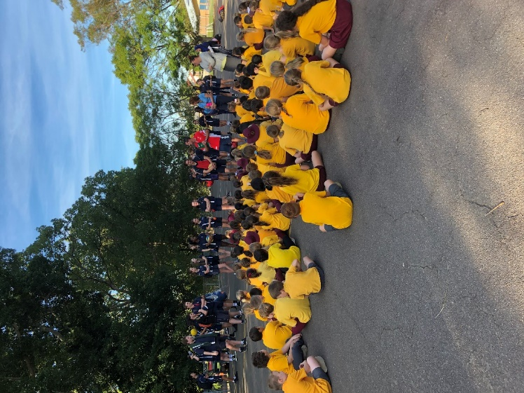
Mr Mick Derry,
PDHPE Head Teacher
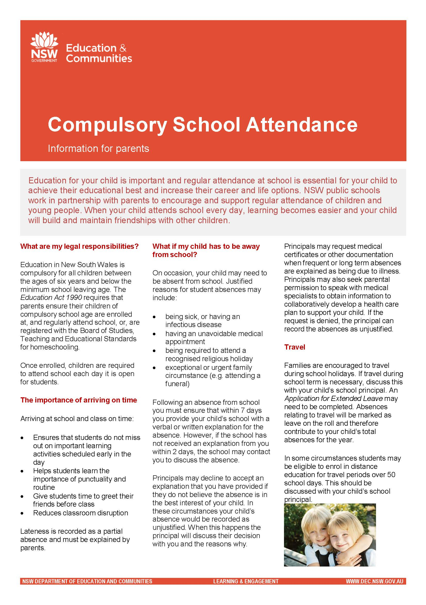
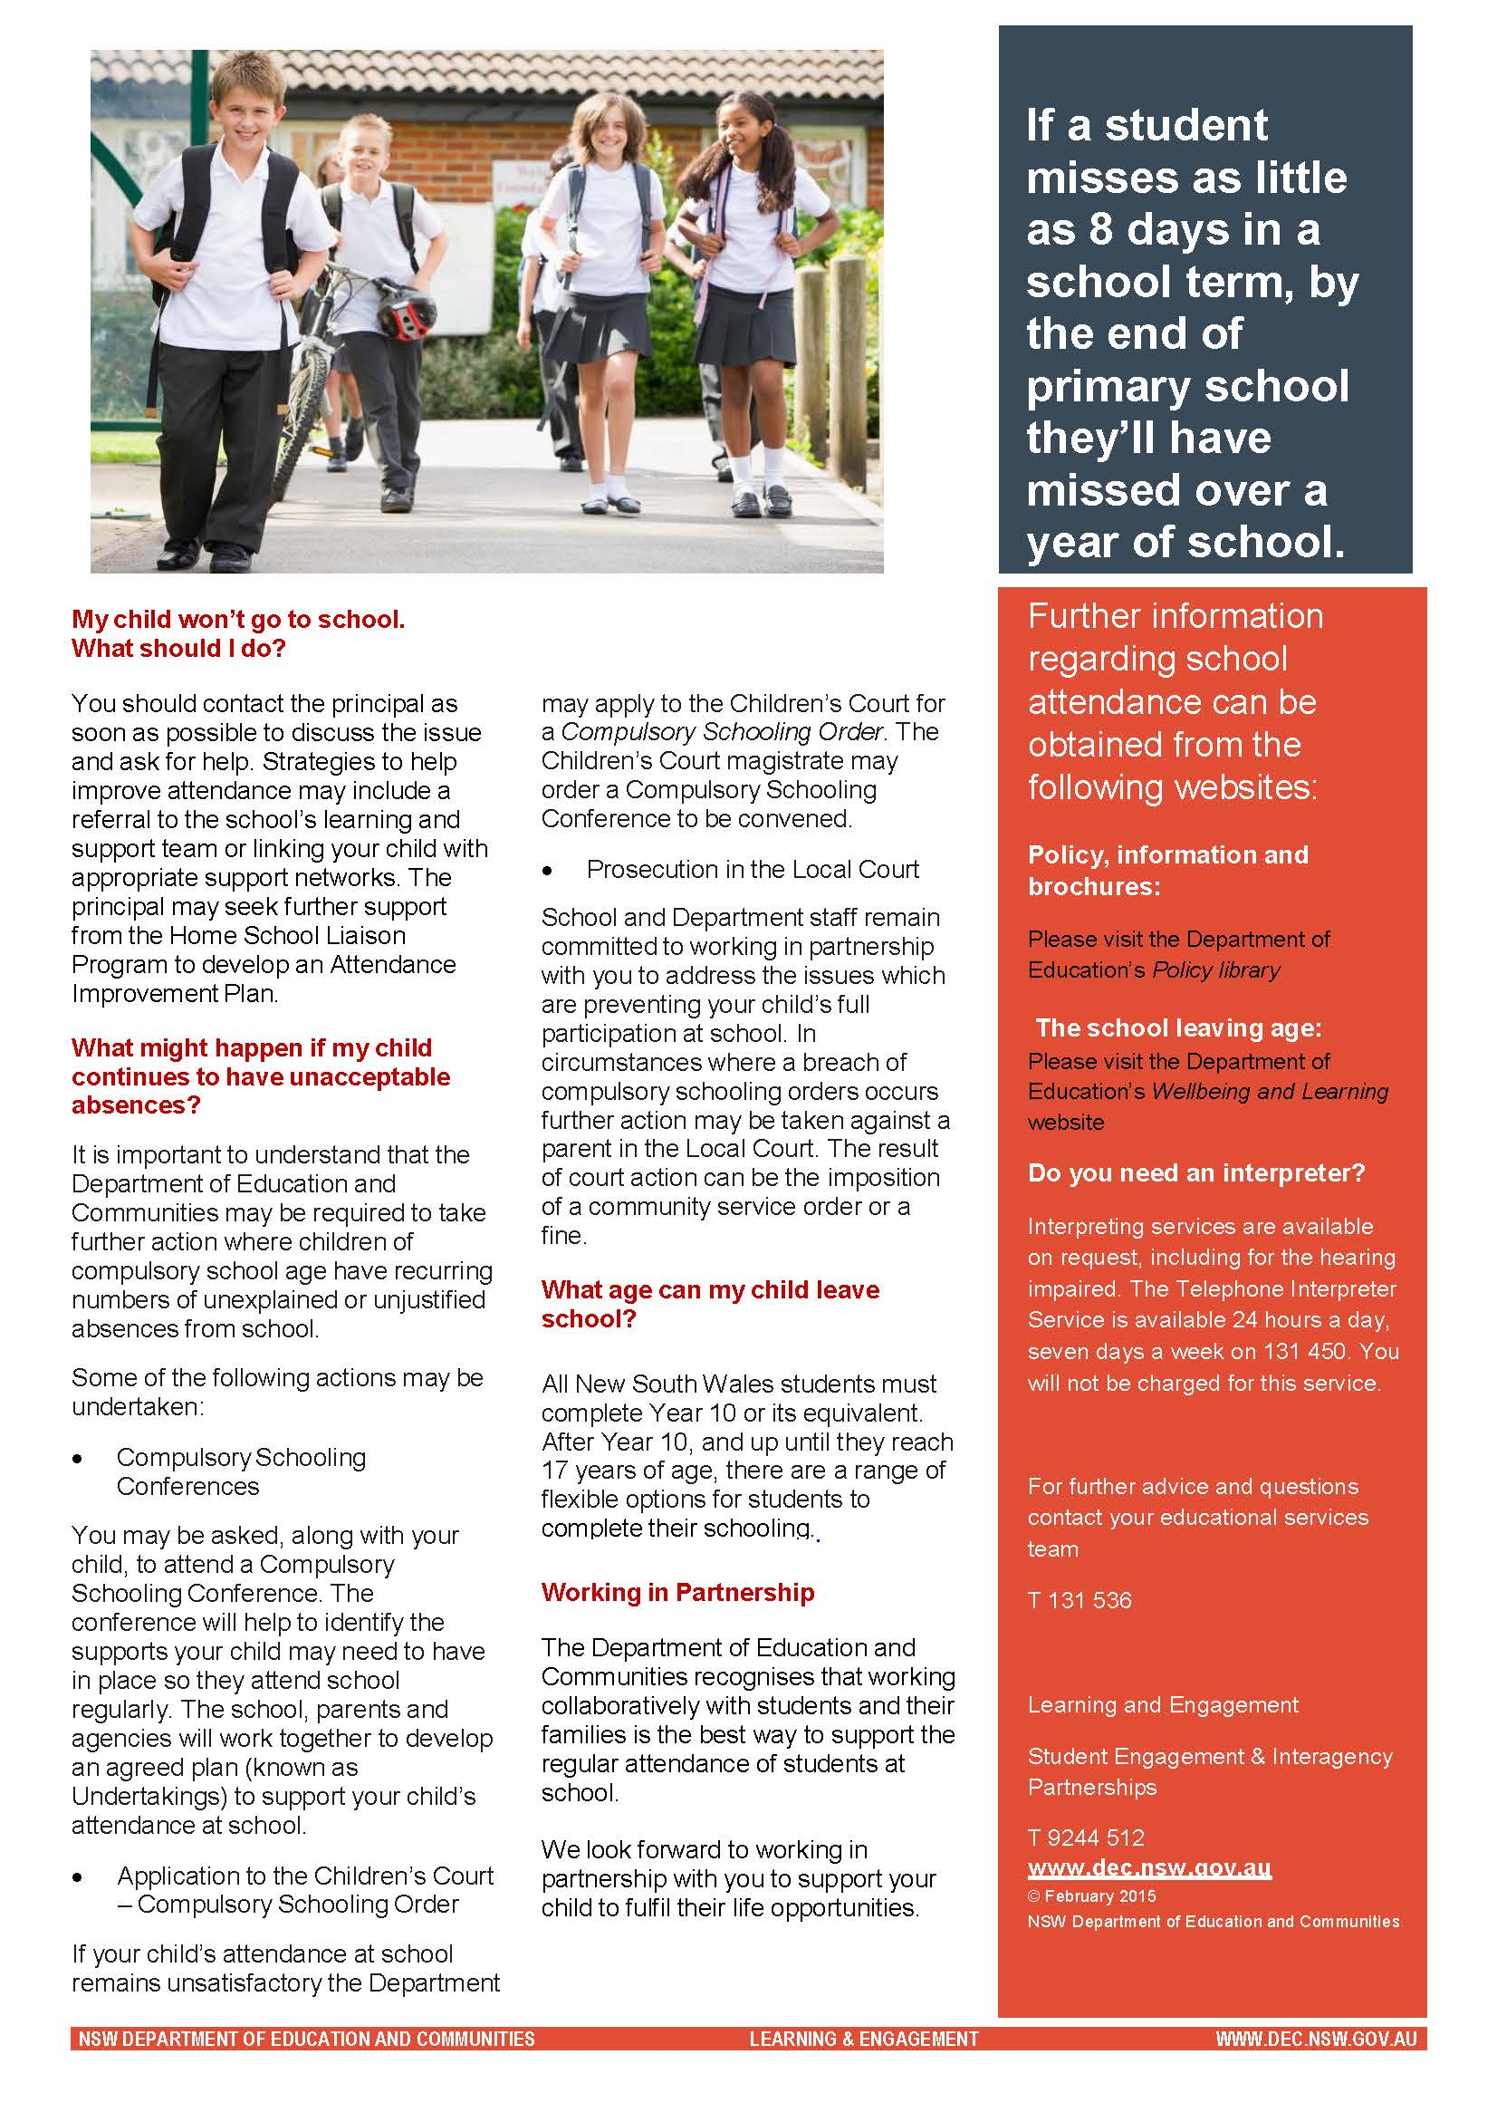
“Feed the Mob Friday” – Slow Cooker Beef Stew Recipe
INGREDIENTS:
- Chuck Roast
- Olive Oil
- Salt & Pepper
- Fresh vegetables including brown onion, celery, garlic, potatoes and carrots
- Tomato paste
- Low-sodium beef or chicken stock
- Worcestershire sauce
- Low-sodium Soy sauce
- Fresh herbs, including thyme, rosemary and sage
- Cornflour
- Frozen peas

METHOD:
- Dab beef dry and season with salt & pepper, brown beef in frypan with olive oil. Transfer to slow cooker.
- Saute onions, celery and garlic and add tomato paste.
- Pour in 1 cup of stock (to deglaze the pan) along with Worcestershire and soy sauce, thyme and rosemary.
- Add potatoes and carrots to slow cooker then pour in stock mixture. Add remaining stock and season with salt & pepper.
- Cook on low heat for 7-8 hours.
- Whisk cornflour with water, stir into stew and cook on high heat for an additional 20 minutes to help thicken slightly. Stir in peas and half of the parsley.
- Serve warm and garnish with remaining parsley

Community Noticeboard
Ingredient  Shop on line and we will hand-pick your groceries, box them with care and deliver them to your door. Or visit our store in Georgetown  Phone 02 49677868  40-46 Georgetown Rd, Georgetown, 2298  Store Hours  Mon-Fri 7.30am-6.00pm  Sat 8.00am-4.00pm  Sun 9.00am-4.00pm  The Fresh Ingredient is a family owned and operated fruit, vegetable and gourmet food store. | Peter and Mary (Proprietors) from  ‘The Fresh Ingredient’

